

**TRIBHUVAN UNIVERSITY**

**Faculty of Humanities and Social Sciences**

**One Stop for Trekking Solution**

**A Project Report**

Submitted to

Department of Computer Application

Janamaitri Multiple Campus

**In partial fulfillment of the requirements for the Bachelor degree in BCA (Bachelors in Computer Application)**

Submitted by

**Laxmi Thami (Registration No: 6-2-263-16-2021)**

**Siddhartha Shakya (Registration No: 6-2-263-29-2021)**

Under the Supervision of

**Kamal Tamrakar**



**TRIBHUVAN UNIVERSITY**

**Faculty of Humanities and Social Sciences**

**Janamaitri Multiple Campus**

**Kuleshwar, Kathmandu.**

## Supervisor’s Recommendation

I hereby recommend that this project has been prepared under my supervision by **Laxmi Thami** **(Registration No: 6-2-263-16-2021)** and **Siddhartha shakya (Registration No: 6-2-263-29-2021)** entitled " **One Stop for Trekking Solution"** in partial fulfillment of the requirements for the Bachelor's degree of BCA (Bachelor of Computer Application) is recommended for the final evaluation.

**………………………………..**

**Kamal Tamrakar**

Supervisor



**TRIBHUVAN UNIVERSITY**

**Faculty of Humanities and Social Sciences**

**Janamaitri Multiple Campus**

**Kuleshwar, Kathmandu.**

## Letter of approval

This is to certify that this project prepared by **Laxmi Thami (Registration No: 6-2-263-16-2021)** and **Siddhartha shakya (Registration No: 6-2-263-29-2021)** entitled " **One Stop for Trekking Solution"** in partial fulfillment of the requirements for the bachelor's degree of BCA (Bachelor of Computer Application) has been evaluated. In our opinion it is satisfactory in the scope and quality as a project for the required degree.

|  |  |
| --- | --- |
| **Signature of Supervisor**  **……………………………..**  Kamal Tamrakar  (Supervisor) | **Signature of HOD/ Coordinator**  **………………………………**  Kamal Tamrakar  (HOD/Coordinator) |
| **Signature of Internal Examiner**  **………………………………..**  Internal Examiner | **Signature of External Examiner**  **………………………………..**  External Examiner |

# Abstract

One Stop Trekking Solution is a comprehensive and user-friendly platform dedicated to catering to the needs of trekking enthusiasts, adventure seekers, and outdoor enthusiasts in Nepal. This website aims to provide a one-stop solution for all trekking-related requirements, offering a wide range of premium trekking gear, equipment, and services. Everything a hiker might possibly need is available, including clothing, boots, sleeping bags, tents, and accessories.

This site stands out as a premier platform, not only offering top-notch trekking gear but also providing a holistic experience for outdoor enthusiasts in Nepal. Whether customers are gearing up for their next trek or seeking expert advice, this website serves as the go-to destination for all things related to trekking in the breathtaking landscapes of Nepal.

Also integrating a blog system into a trekking business platform in Nepal offers numerous benefits. The blog can provide informative content about trekking routes, safety guidelines, and gear recommendations, attracting and engaging users. It becomes a platform for trekkers to share their experiences and tips, fostering a sense of community. By featuring local culture, festivals, and traditions, the blog establishes a connection between trekkers and the unique aspects of Nepal.

## Acknowledgement

We extend our sincere gratitude to all those who contributed to the development of this project. First and foremost, we express our heartfelt thanks to the Department of Bachelors of Computer Applications for their indispensable support and resources, without which this project would not have been possible. We also acknowledge the invaluable guidance and mentorship provided by **Mr. Kamal Tamrakar** throughout the duration of this project. His expertise and insights have been instrumental in shaping our approach and achieving our objectives. Additionally, we appreciate the collaboration, dedication, and hard work of each team member. Our combined efforts have been crucial in bringing this project to fruition.

Furthermore, the authors would like to express their sincere gratitude to **Kamal Tamrakar**, Head of Department at Janamaitri Multiple Campus, for his unwavering support, guidance, and valuable insights during the conceptualization of this project. His leadership and encouragement were instrumental in shaping the direction of our work.

Special thanks are extended to **Abita kunwar** Madam for her expertise and assistance in database management and entity-relationship modeling, significantly enhancing the technical aspects of our project.

Additionally, we acknowledge **Subigya Ojha** Madam for her creative insights and contributions to the design elements of our platform. Her expertise in designing played a crucial role in making the learning environment interactive and visually appealing. Specifically, her assistance during the creation of the Data Flow Diagram (DFD), system layout, and system design has been invaluable.

This work would not have been possible without the collaborative efforts and support of these individuals. Their contributions have played a pivotal role in the successful formulation of this proposal and will undoubtedly impact the success of the subsequent project

# List of Figures

Figure 1: Waterfall Model 3

Figure 2: ER Diagram 7

Figure 3: Use Case Diagram 8

Figure 4: Database Schema 9

Figure 5: DFD Level 0 10

Figure 6: DFD Level 1 10

Figure 7: Gantt Chart 11

# Abbreviation

CRUD: Create, Read, Update, Delete

DFD: Data Flow Diagram

ER Diagram: Entity Relation Diagram

HTML: Hypertext Markup Language

Contents

Supervisor’s Recommendation i

Letter of approval ii

Abstract iii

Acknowledgement iv

List of Figures v

Abbreviation vi

1.1 Introduction 1

1.2 Problem Statement 1

1.3 Objectives 2

2 Literature Review 2

3 Methodology 3

A. Requirement Identification 3

i. Study of Existing System 3

ii. Requirement Collection 4

Functional Requirements 4

Non-Functional Requirements 4

B. Feasibility Study 5

i. Technical Feasibility 5

ii. Operational Feasibility 5

iii. Economic Feasibility 6

C. High-level Design of System 6

Gantt Chart 11

Expected Outcome 11

Reference 12

**Chapter 1: Introduction**

## Introduction

"One Stop for Trekking Solution" are ambitious projects aimed at providing outdoor enthusiasts with a comprehensive and seamless platform for purchasing high-quality trekking equipment. Our goal is to offer convenience, expertise, and reliability by sourcing a diverse range of products, including Nepali-made gear known for its quality craftsmanship and durability. Through user-friendly interfaces and secure transactions, we aim to cater to the diverse needs of trekkers, both locally and internationally. This proposal outlines our commitment to delivering a superior shopping experience while promoting Nepali craftsmanship on a global scale.

## 1.2 Problem Statement

Despite Nepal's reputation for hosting some of the world's most awe-inspiring treks, such as the legendary Everest Base Camp and Annapurna Circuit, trekkers frequently encounter challenges in accessing reliable information, acquiring suitable gear, and experiencing authentic local culture. Existing platforms often lack specialization in Nepal and overlook its unique trekking culture. Our project, One Stop for Trekking Solution, aims to address these issues by offering curated gear selections suited to Nepal's diverse terrains, providing personalized recommendations tailored to user preferences, and promoting cultural immersion opportunities to foster responsible tourism and support local communities.

## **1.3Objectives**

* Establish an online platform that specializes in offering Nepali-made trekking equipment.
* Emphasize quality, affordability, and accessibility in the selection of products and Promote Nepali craftsmanship and support local artisans.

## **1.4 Scope and Limitations**

* Dependency on third-party suppliers and logistics may lead to delays.
* Security vulnerabilities in online transactions.
* Competition from established offline and online retailers.

## Chapter 2: Background Study and Literature Review

**2.1 Background Study (Description of fundamental theories, general concepts, and terminologies related to the project)**

Our literature review encompassed an in-depth exploration of various online platforms and websites to garner insights into the landscape of trekking equipment sales in Nepal. Notable platforms such as trekkinggearnepal.com, parikramatreks.com, insidehimalayas.com, and trekkingtrail.com provided invaluable data concerning product diversity, pricing strategies, and consumer preferences prevalent within the Nepalese market. By meticulously analyzing these platforms, we were able to identify scope for improvement, pinpoint potential mistakes, and ascertain prevailing price trends, thereby enriching our understanding of the market dynamics.

Furthermore, our review extended beyond domestic boundaries to include global travel websites, offering valuable insights into international trends and customer expectations within the trekking equipment industry. This broader perspective allowed us to discern emerging patterns and preferences that could potentially influence our project's success.

Moreover, delving into prominent online marketplaces such as Daraz, dolpo.com.np, mtnoutdoors.com.np, and Nepal Adventure Team Pvt. Ltd. provided invaluable firsthand insights into the current market offerings and pricing trends. By scrutinizing these platforms, we were able to glean crucial information regarding competitor strategies, consumer behavior, and emerging market trends.

Through synthesizing information from these diverse sources, we have cultivated a comprehensive understanding of the market landscape, enabling us to delineate clear objectives and devise effective strategies for the successful establishment of our online platform for trekking gear sales in Nepal.

## Methodology

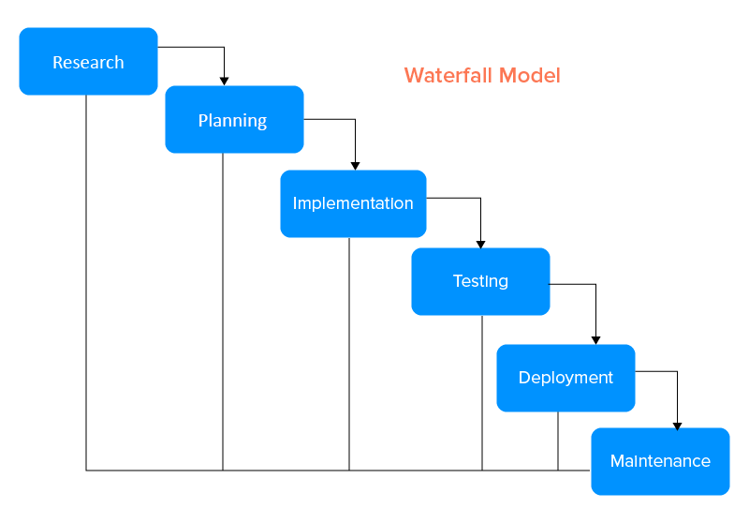When developing the website, we'll follow the waterfall Model. Because this project has clear objectives, detailed documentation, and well-understood technology, so waterfall model is best suited.

#### Figure 1: Waterfall Model

## Requirement Identification

### Study of Existing System

* **Market Research and Analysis:**

To comprehend the present trends, needs, and rivalry in Nepal's trekking equipment and adventure tourism sectors, we will carry out in-depth market research. Examine consumer inclinations, rival products, and market gaps to mold the product line and services.

* **Limitations:**

Examine the current hiking marketing system in more detail to learn about its shortcomings in relation to a number of areas, including the demands and desires of customers and the system for managing items. In addition to lacking characteristics

* **Area of Improvements:**

Genuine goods, a user-friendly layout with less advertisements, and well-curated content for hikers and trekkers

### Requirement Collection

To obtain information about the particular requirements and expectations of the target audience, conduct interviews with trekking enthusiasts, adventure trip operators, and subject matter experts. This data is essential for customizing the product offerings and designing enticing hiking packages. As well as Form alliances and joint ventures with respectable vendors and well-known brands in the hiking and outdoor equipment sector. Reach arrangements for the provision of premium goods, guaranteeing a varied and superior inventory for the clients.

## Functional Requirements

* Integration with local payment gateways that are commonly used in Nepal.
* Optimize the web application for users with varying internet speeds, especially in remote trekking regions.
* Feature and promote local trekking gear brands and products.
* Implementation of blog feature highlighting Nepali landscapes and terrains

## Non-Functional Requirements

* With clear labeling and directions, the user interface should be simple to use and intuitive.
* To provide a seamless user experience, response times for search queries and page loading should be minimized.
* Sensitive information, such user passwords, should be protected with data encryption.
* The website needs to be built with ease of scalability in mind, able to handle a rising number of users and products.

## Feasibility Study

### Technical Feasibility

The technical feasibility study will determine whether our suggested trekking e-commerce website is compatible with already-existing websites of a similar nature. HTML will be used to create the Web application, together with CSS for the graphical user interface and PHP Mysql for database connectivity. By ensuring platform independence, the system may be adjusted to work in a variety of operating conditions.

We will also evaluate the technological viability in terms of performance and scalability. The application can be scaled as the volume of data increases thanks to the selected technologies, and responsive user experience will be ensured through optimizations.

**Languages:** HTML and CSS will be our main programming languages. These languages allow us to create extremely responsive, flexible, and interactive website.

**Database:** Since MySQL offers a scalable and dependable option for storing data about various hiking equipment and user information, we will utilize it as the backend database management system.

**Scalability:** With scalability in mind, the architecture will be created such that the system can manage an increasing number of Products and transactions without experiencing performance issues.

Utilizing well-known and extensively used languages guarantees a reliable and expandable solution. The web application will also have an extendable and modular architecture to support upgrades and enhancements in the future.

### Operational Feasibility

Operational Feasibility is centered on creating highly adaptable and user-friendly websites that capture the variety of Nepal's terrain using the right tools and equipment. Our software seeks to expedite processes associated with browsing and purchasing different types of equipment. Also, implementation of blog feature further enhances user experience. The smooth navigation menu and dynamic user interface is an important operating feature.

**Operational Factors:**

* Interfaces that are simple to use for viewing products.
* Seamless navigation and quick access to CRUD functions.
* Effective ordering, changing, and purchasing system.
* Implementation of blog system of Nepali landscape

Potential end users will participate in usability testing of the web application to make sure it satisfies operational needs and improves the general effectiveness of product management.

### Economic Feasibility

Economic Feasibility examines the financial elements of deploying Trekking equipment web application. The costs of growth and upkeep will be thoroughly examined, with attention given to the typical budgets of both foreign and Nepalese citizens, as well as other expenses and product pricing.

## High-level Design of System

Our approach to building the website is focused on building a stable and intuitive platform that allows hikers and trekkers to effectively handle a variety of gear and items categorized into different categories guarantee a smooth and simple user experience

**Entity Relation Diagram**

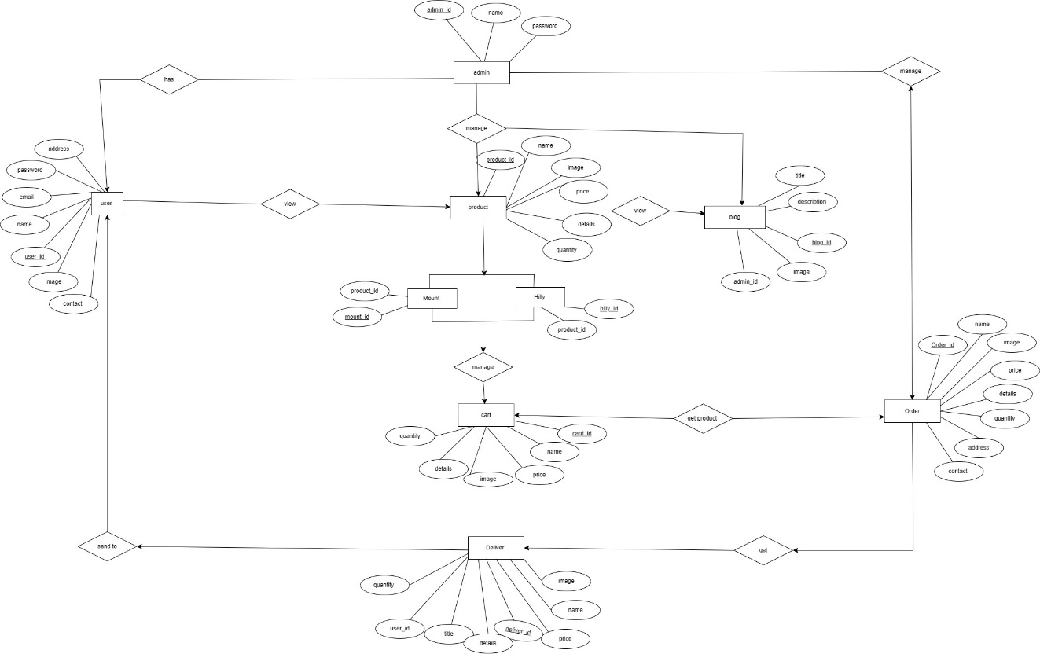

#### 

#### Figure 2: ER Diagram

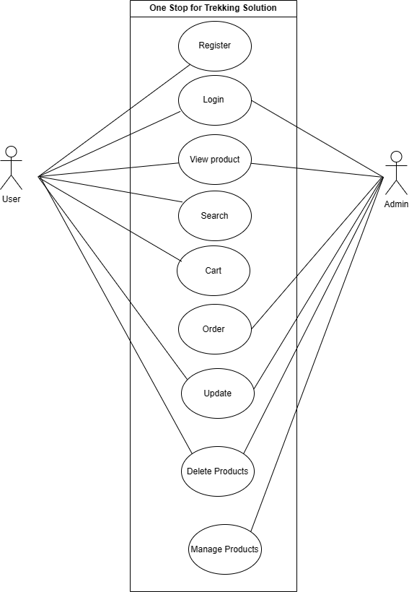**Use case Diagram**

#### Figure 3: Use Case Diagram

**Database Schema**

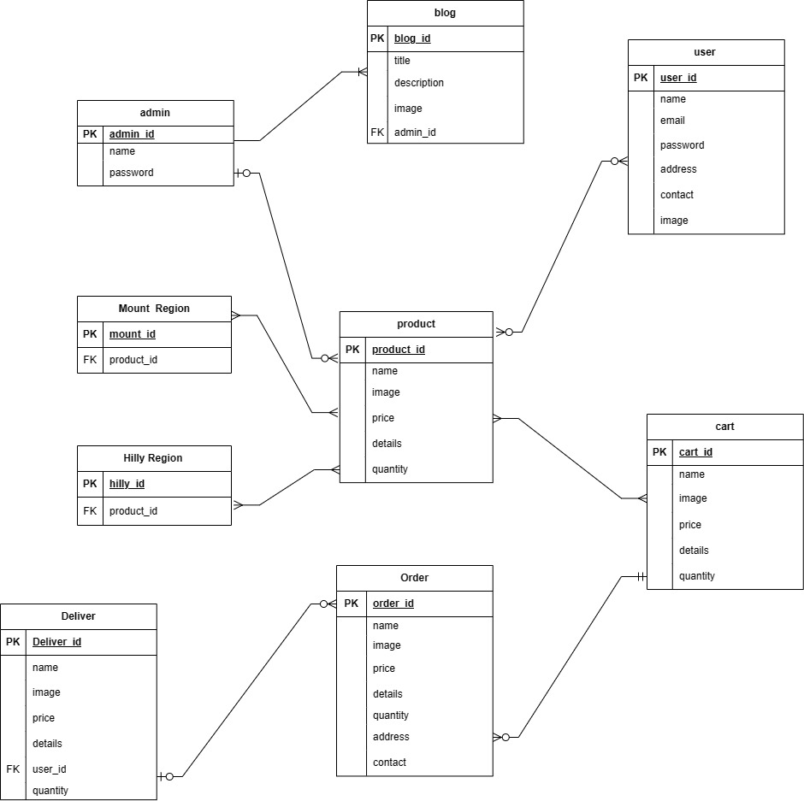

#### Figure 4: Database Schema

**Data Flow Diagram**

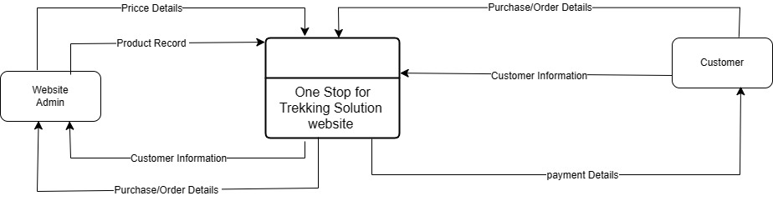

#### Figure 5: DFD Level 0

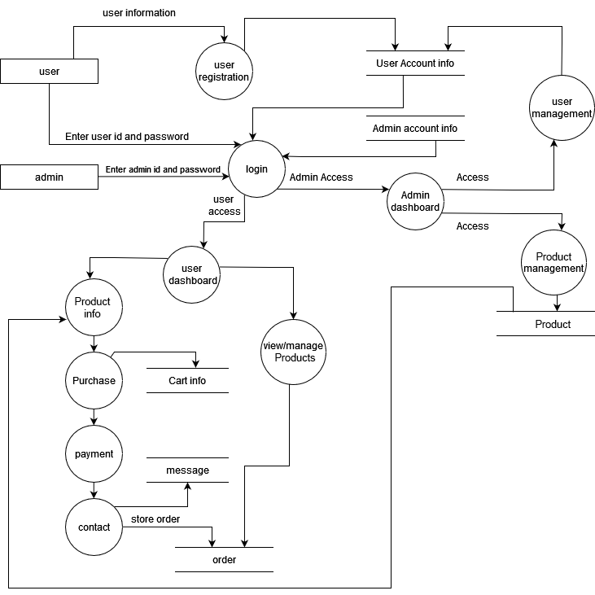

#### Figure 6: DFD Level 1

#### 

|  |  |  |  |  |  |  |  |  |  |  |
| --- | --- | --- | --- | --- | --- | --- | --- | --- | --- | --- |
| Weeks | 1-2 | 2-4 | 4-6 | 6-8 | 8-10 | 10-12 | 12-14 | 14-16 | 16-18 | 18-20 |
| Planning |  |  |  |  |  |  |  |  |  |  |
| Analysis |  |  |  |  |  |  |  |  |  |  |
| Design |  |  |  |  |  |  |  |  |  |  |
| Coding |  |  |  |  |  |  |  |  |  |  |
| Testing |  |  |  |  |  |  |  |  |  |  |
| Delivery |  |  |  |  |  |  |  |  |  |  |
| Documentation |  |  |  |  |  |  |  |  |  |  |

## Gantt Chart

#### Figure 7: Gantt Chart

## Expected Outcome

**Cultural and Local Engagement:**

* A focus on using carefully chosen trekking experiences to promote and protect Nepal's rich cultural and ecological heritage.
* Partnerships with regional companies and craftsmen to market and sell genuine Nepalese goods in addition to hiking equipment.

**Community Involvement:**

* Contribution to local communities through sustainable tourism practices.
* Support for community projects and initiatives that benefit the regions where trekking activities take place.

**Participation in Tourism Promotion:**

* Involvement in events and campaigns that promote Nepal as a trekking destination.
* Encouraging and showcasing positive customer experiences through reviews and testimonials.
* Continuous improvement based on customer feedback to enhance the overall trekking experience.

## Reference

[1] Ghimire, S., & Shakya, S. (2020). "Impact of E-Commerce on Local Product Promotion: A Case Study of Nepal." Journal of International Business Research and Marketing, 5(1), 23-28.

[2] Government of Nepal. (2019). "National Strategy for Promotion of Micro, Small, and Cottage Industries in Nepal." Ministry of Industry, Commerce, and Supplies.

[3] Karki, R., & Shrestha, P. (2018). "Role of E-commerce in Promoting Nepalese Handicrafts: A Study on Social Media and Online Shopping Platforms." International Journal of Scientific and Research Publications, 8(11), 473-478.

[4] Pant, R., & Pokharel, B. (2017). "Promotion of Local Products through E-commerce in Nepal: A Study on Opportunities and Challenges." Journal of Business and Social Sciences Research, 2(1), 12-19.

[5] Pokharel, A. (2019). "Role of Digital Marketing in Promoting Nepali Handicrafts: A Case Study of Selected Handicraft Businesses in Kathmandu Valley." Nepal Journal of

Business, 6(1), 25-35.